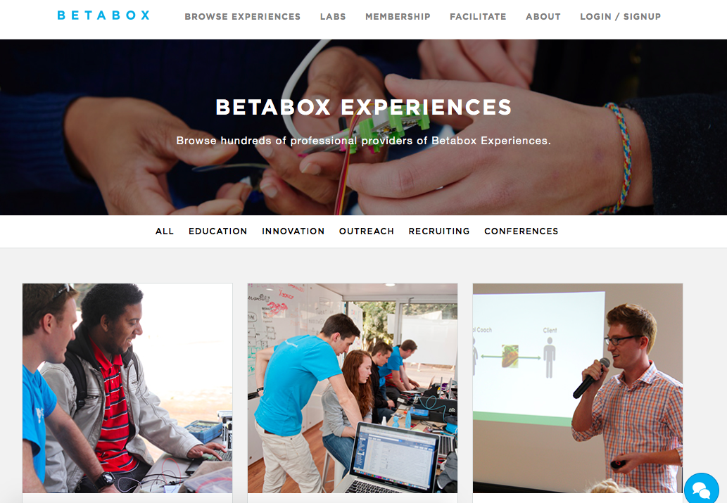

OVERVIEW
Betaversity or Betabox is a mobile prototyping company led by CEO Sean Maroni. He went to school at NC State for a major in mechanical engineering however his interests reach many other fields and majors. As a student he became interested in running creative spaces. Sean came up with this idea along with more students he met through epicenter. They decided to create a makers pace that was portable. Thus Betabox was born. It is the first transportable makers space.

PURPOSE
The purpose of Betabox is to inspire creativity and design thinking around the country in affordable and transportable ways through mobile creative spaces. Betabox offers a wide variety of tools and spaces that can help corporations and students alike to solve real world problems.
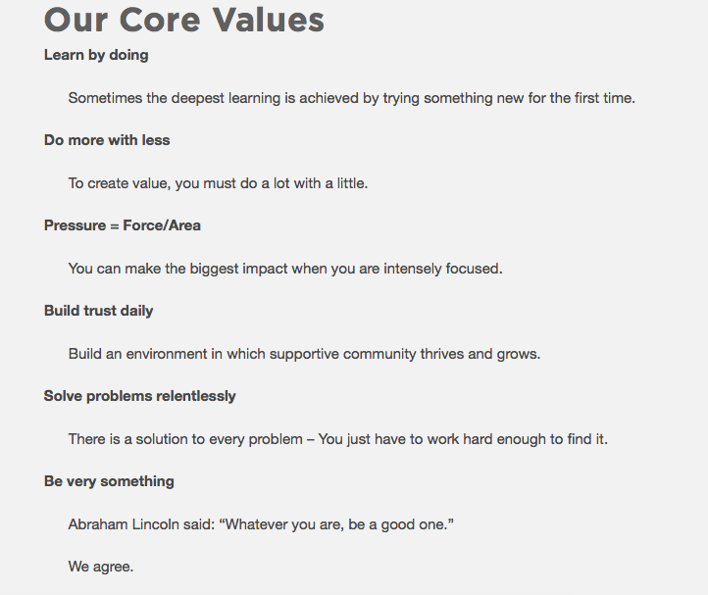

DISTINCT DIFFERENCES FROM OTHER OFFERINGS
Betabox is portable unlike any other competitor and they serve all sorts of industries. They help corporations with engineering issues and they help students start businesses. The most interesting part of Betabox compared to competitors is their adaptability. Betabox can do anywhere in the country! Imagine a freestanding makers space delivered to your doorstep anytime you want!
ACADEMIC PERMISSION
The Betabox can be found around the country. It was originally tested at UC Davis and then taken over as a consulting project by Sean and his cohorts. In the beginning they saw a growing demand for their idea. They realized students and schools were looking for news ways to get their own creative spaces. But schools also realized that making your own space can be expensive so Betabox began to rent their to different schools in the university and K-12 setting. 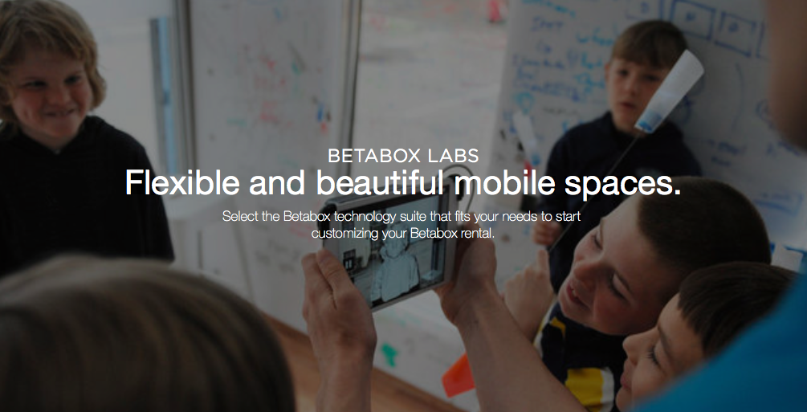

STEPS REQUIRED TO BRING RESOURCE TO CAMPUS
This didn’t come easy. Sean and Betabox knew early on that they needed to work and build good relationships with everyone in power of making the decisions at the university setting. They also knew that they would need to bring the best materials and thought leaders to their boxes in order to inspire innovation and design thinking.

With that in mind Betabox has grown to a larger scale! It has taken on many different forms for leaders and thinkers in many different academic backgrounds. They have created modular boxes for makers, ideators, and others with many different specifications. Betabox have also connected students to the necessary information to grow their ideas.

But it didn’t stop there. Betabox made it a goal to inspire kids to lead in their own entrepreneurial community. They realized their product was most useful when students went out of their way to build more upon what Betabox had started. Sean has said that his most important lessons came from his customers. It was the students, teachers, and engineers that used his box that were able to tell him how to best use it.
CONTACT INFORMATION
You can find more about Betabox through their website betaboxlabs.com. If you want to get in contact with the CEO, Sean Maroni, feel free to email the UIF representative at gtj5@pitt.edu for more information.
CONCLUSION
In the end Betabox has a ton of room to grow as a company. You can visit their website to learn more and potentially get a Betabox somewhere near you. Sean is a very well spoken leader and has a lot knowledge in the makers space realm. He offered a lot of valuable information and he left some tips for anyone interested. He wanted to say “you need to listen to your customers, experiment and iterate, and make sure to facilitate the growth and design of products in a fun atmosphere.” Simply put he is trying to remind us all that innovation is collaborative and fun. Betabox is all about making memorable and educational experiences for everyone involved from the CEO to the student to the teacher. If you ever have the desire to brainstorm an idea make sure to look up where the closest BetaBox is near to you! Keep a lookout for Betabox 2.0 coming soon!

